**BIRLA INSTITUTE OF TECHNOLOGY AND SCIENCE, PILANI**

Batch No. :

**DEPARTMENT OF COMPUTER SCIENCE AND INFORMATION SYSTEMS**

**Artificial Intelligence (BITS F444/ CS F407)**

**I Semester 2019-20**

**Programming Assignment-1**

**Coding Details**

**(September 10, 2019)**

*Instruction: Type the details precisely and neatly*

1. ID 2017A7PS0171P

Name PRATEEK SHARMA

1. Mention the names of Submitted files :
   1. Finalsubmission.py
2. Total number of submitted files: 1
3. Name of the folder :2017A7Ps0171P
4. Have you checked that all the files you are submitting have your name in the top?(yes/no) yes
5. Have you checked that all the files you are submitting are in the folder as specified in 4 (and no subfolder exists)?(yes/no) yes
6. Problem formulation
   1. State representation: IN A LIST(DIRTY TILE=1)- AS N*N TUPLE
   2. How is the Initial state generated?- THROUGH RANDOM GENERATOR FUNCTION
   3. What is the goal state? ALL FIRST 100 ELEMENTS OF LIST AS 0
   4. Are there more than one goal states? -NO
   5. If yes, then describe all the goal states -
   6. State representation in Python (name the construct and give one small example of a state)-
7. Successor function description: BASED ON RIGHT, LEFT,UP,DOWN ACTION IT CREATES SUCCESSOR
8. BFS (T1) details
   1. Is the search applied on tiles or on states? STATES
   2. Error handling and reporting (yes/No): NO
   3. List the errors handled:
   4. Data Structure description for the tree node (in maximum two lines): I USED LIST, QUEUE USING LIST
   5. Code status (implemented fully/ partially/ not done) :IMPLEMENTED
   6. Maximum depth reached before the failed memory allocation, if happened any? NO
   7. Maximum room size you are able to handle to reach the goal state within available memory and reasonable time: 9
   8. Other limitations of the technique:
9. IDS (T2) details:
   1. Is the search applied on tiles or on states? states
   2. Error handling and reporting (yes/No): no
   3. List the errors handled:
   4. Data Structure description for the tree node (in maximum two lines): list as a node
   5. Code status (implemented fully/ partially/ not done): implemented
   6. Maximum depth reached before the failed memory allocation, if happened any?60
   7. Maximum room size you are able to handle to reach the goal state within available memory and reasonable time: 9
   8. Other limitations of the technique:
10. GUI details
    1. Created the GUI ?(yes/ N0):YES
    2. Have you created it according to the specifications?(yes/No):YES
    3. Which module of Python is used for creating graphics?: TKINTER
    4. Is this under the standard Python library or not?:YES
    5. If not, why?
    6. Are the window panes working independently?:YES
11. Graphics details:
    1. Is turtle/PyQT graphics working fine for movement of the intelligent vacuum cleaner?NOT USED
    2. How are you creating the room tiles?:WITH CREATE_RECTANGLE FUNCTION
    3. How are you showing the dirt?:YES
    4. How are you showing the resting position of the vacuum cleaner?:NO
    5. Are you showing the movement of the vacuum cleaner (turtle cursor) as the execution of T1 goes on? Why or why not?::YES, IN TKINTER I AM MOVING THE CLEANER
    6. Are you showing the movement of the vacuum cleaner (turtle cursor) as the execution of T2 goes on? Why or why not?:YES
    7. Which functions of Matplotlib are you using? :addsubplot()
    8. Are you using any other library such as NUMPY other than the standard Python, PyQT5 and Matplotlib?:No
    9. Any other details:
12. Compilation Details:
    1. Code Compiles (Yes/ No):________yes______
    2. Mention the .py files that do not compile:____none
    3. Any specific function that does not compile:______none
    4. Ensured the compatibility of your code with the specified Python version(yes/no)_____yes
    5. Instructions for compilation of your files mentioning the multi file compilation process used by you (We may use the replica of these for compiling your files while evaluating your code):: one file only compile that file
13. Driver Details: Does it take care of the options specified earlier(yes/no):yes
14. Execution status (describe in maximum 2 lines)
15. Output Details
    1. 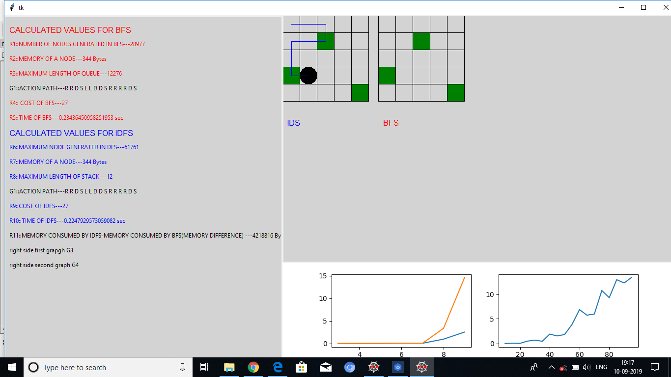Copy and paste the output of four graphs G1-G4 here

Write some more details here for the above graphs, if needed

* 1. Write the following values computed by you (refer the details of R1-R11 in the assignment document). Use appropriate units for the values

R1: 28977 R2: 344 bytes R3: 12776 R4:27

R5: 0.234 sec R6: 61761 R7: 344 bytes R8:12

R9: 27 R10: 0.224 sec R11: 4218816 R

For 5*5 with 3 dirty tiles

1. Declaration: I, PRATEEK SHARMA (name) declare that I have put my genuine efforts in creating the python code for the given programming assignment and have submitted only the code developed by me. I have not copied any piece of code from any source. If the code is found plagiarized in any form or degree, I understand that a disciplinary action as per the institute rules will be taken against me and I will accept the penalty as decided by the department of Computer Science and Information Systems, BITS, Pilani.

ID__2017A7PS0171P Name:PRATEEK SHARMA

Date: 10 AUG 2019

******************************************************************************* Should not exceed FOUR pages